Quality Area 2: Children’s Health and Safety- Standard 2.2, 2.1.2 Administration of First Aid.
Policy Statement:
The First Aid Policy, strategies and practices are designed to support educators to:
- Ensure that ill or injured persons are stabilised and comforted until medical help intervenes
- Monitor ill or injured persons in the recovery stage
- Apply first aid strategies if the condition does not improve
- Ensure that the environment is safe and that other persons are not in danger of becoming ill or injured
Goals: (What are we going to do?)
First Aid can preserve life, prevent a condition worsening and promote recovery. The capacity to provide prompt basic first aid is important in the context of our Preschool where staff have a duty of care to take positive steps towards maintaining the health and safety of each child.
Strategies:
In accordance with the National Regulations 136(1)
- All educators hold current first aid certificates and are in attendance at any place where children are being educated and cared for by the service, and immediately available in an emergency, at all times that children are being educated and cared for by the service. All full time educators including the nominated supervisor / Director have undertaken current approved asthma and anaphylaxis management training
- First aid qualifications must be approved through an approved provider deemed so by ACECQA
- The service informs children, families and educators of those who hold first aid qualifications
- Copies of current staff aid qualifications are stored in the staff records.
First Aid Action Response:
Generally, first aid is provided in response to unpredictable illness or injury.
Educators have an obligation to ensure parents and guardians are informed about first aid provided to their children
The Need for an Ambulance:
An ambulance will be called when the following instances (but not limited to) occur to a child or a person at the service.
- Unconsciousness or an altered conscious state
- Experiencing difficulty breathing
- Showing signs of shock
- Experiencing severe bleeding, or is vomiting or passing blood
- Slurred speech
- Serious injuries to the head, neck or back
- Possible broken bones
Infection and Prevention Control
Adequate infection and prevention control must be practiced at all times when administering first aid or cleaning up blood or body fluids.
The following must be adhered to:
- Clean and cover cuts and abrasions with waterproof occlusive dressing to avoid contamination of cuts and abrasions with another person’s blood and/or body fluids
- Wear protective gloves when in contact with body fluids, non-intact skin and mucous membranes.
- Wear a mask and eye protection where there is a risk of splashing blood or other body fluids
- Remove any broken glass or sharp materials with forceps or tongs and place in container and;
- Wash hands thoroughly after direct contact with injured person or blood/body fluids with warm soapy water, rinse, dry and sanitise hands using an alcohol-based gel or rub
Poisons Information Centre
The Poisons Information Centre telephone number is 131 126 is displayed:
- Next to every telephone in the service
- Where dangerous products are stored
Roles and Responsibilities:
Approved Provider
- Ensuring that every reasonable precaution is taken to protect children at the service from harm and hazards likely to cause injury (Section 167)
- Ensuring that a least one educator or nominated supervisor of the service with current approved first aid qualifications is in attendance and immediately available at all times that children are being cared or educated by the service (Regulation 136(1) (a)). This can be the same person that has anaphylaxis and asthma management training (required under regulations).
- Appointing an educator as the first aid officer.
- Advising families that a list of first aid and other health products used by the service is available for their information and that first aid kits can be inspected on request.
- Providing and maintaining an appropriate number of up to date, fully equipped first aid kits that meet Australian Standards
- Providing and maintaining an up to date, fully equipped portable first aid kits that meet Australian Standards that can be taken on excursions or off site for other activities.
- Ensuring that first aid training details are recorded on each staff members record.
- Ensuring safety signs showing location of the first aid kits are clearly displayed
- Ensuring there is an induction process for all staff, casual and relief staff that includes providing information on location of first aid kits and specific first aid requirements
- Ensuring a resuscitation flow chart is displayed in a prominent position in the indoor and outdoor environments of the service
- Keeping up to date with any changes in procedures for administration of first aid and ensuring that all educators are informed of these changes.
- Notifying the regulatory authority of any serious incidents meaning an incident or class of incidents prescribed by the National Regulations as a serious incident within 24 hours.
Roles and Responsibilities continued:
Nominated Supervisor:
- Ensuring that all staffs approved first aid qualifications, anaphylaxis management training and emergency asthma management training are current, meet the requirements of the National Act (Section 169(4)) and national regulations (Regulation 137) and are approved by AECQA
- Ensuring a portable first aid kit is taken on all excursions and other off- site activities
Nominated First Aid Officer & Full time Educators:
- Maintaining a current approved first aid qualification.
- Monitoring the contents of the first aid kits and arranging with the Director for replacements of stock, including when the use by date has been reached.
- Disposing of out date materials appropriately
- Ensuring a portable first aid kit is taken on all excursions and other off-site activities.
- Keeping up to date with any changes in the procedures for the administration of first aid
- Wear protective gloves when in contact with body fluids, non-intact skin and mucous membranes
- Remove any broken glass or sharp material with forceps or tongs and place in a container
- Wash hands thoroughly after direct contact with an injured person or body fluids/blood with warm soapy water, rinse, dry and sanitise hands using an alcohol – based rub or gel.

SOURCES:
⊲ ACECQA – www.acecqa.gov.au/first-aid-qualifications-and-training
⊲ Guide to the National Law and National Regulations
⊲ Australian Red Cross – www.redcross.org.au
⊲ St John Ambulance Australia(NSW) – www.stjohnnsw.com.au
⊲ First aid in the workplace – www.safework.nsw.gov.au/health-and-safety/manage-workplace-safety/ first-aid
Related Legislation
⊲ Education and Care Services National Law Act 2010: Sections 167, 169
⊲ Education and Care Services National Regulations 2011: Regulations 87, 89, 136, 137(1)(e), 168(2)(a), 245
⊲ Work Health and Safety Act 2011
⊲ Children and Young Persons (Care and Protection) Act 1998

OUR PHONE NO. 0269227489
USEFUL CONTACTS:
IN CASE OF EMERGENCY PHONE 000 or 112 (mobile)
Give address cnr of Fife Street and Brunskill ave FOREST HILL
Closest main road Sturt Highway – turn opposite Forest Hill Public School into Fife St and follow to end and turn into park at Preschool sign.
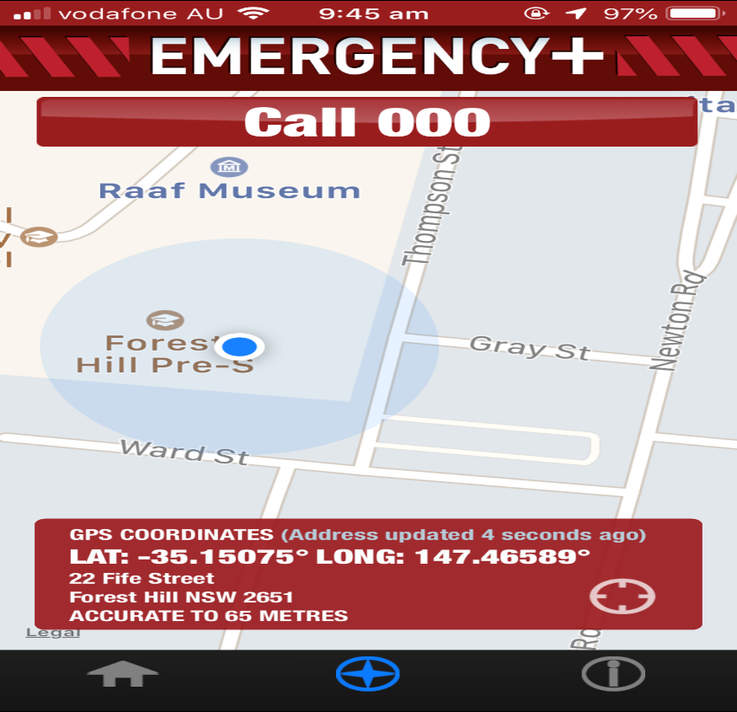
POISONS INFORMATION CENTRE: 131 126
SECPOL: 0427343350
BASE COMMAND: 0269375888
RAAF FRONT GATE: 02 69374566
WAGGA POLICE: 02 69222599
WAGGA VETERINARY SERVICES: 0269260900
PLUMBER: Andrew Smith 0404049480
WAGGA CITY COUNCIL: 1300292442
ELECTRICITY DISRUPTION: 132080
WATER DISRUPTION: 0269220608

